South Row School

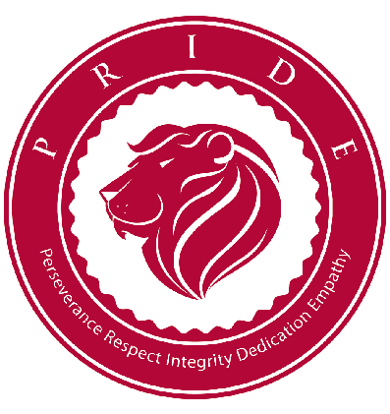
Dr. Molly McMahon, Ph.D. Principal 250 Boston Road
Chelmsford, Massachusetts
Tel: (978) 251-5177

January 22, 2018

Dear South Row Kindergarten Parents and Guardians,

In January, the Chelmsford Elementary Guidance Counselors will begin to teach a personal safety program that is highly regarded by parents, educators, counselors, school nurses and child safety organizations. The program is called the safe TOUCH program. The focus of the safe TOUCH program is safety and the development of assertiveness skills.

The lessons are designed to empower and educate children and will cover the following
concepts:

- Comfortable/uncomfortable touch, words, and pictures
- Recognizing "icky" or uncomfortable feelings
- Anything covered by a bathing suit and our mouth are private parts
- Identifying safe, trusted adults
- Feeling confident to implement the “No! Go! Tell!” plan
- If someone breaks the safety rules it is not the child ‘s fault

If you have questions about the content of the program, feel free to contact Dr. Linda Rich,
the Counselor at South Row. We feel this program will help us work together as partners toward the common goal of protecting our children.

Sincerely,
The Kindergarten Team and Dr. Linda Rich

